Welcome To
Trinity Lutheran Church
Lutheran Church - Missouri Synod
A Stephen Ministry Congregation

1354 South Otsego Avenue
Gaylord, MI 49735
Church Phone: 989-732-4816

Church Email: secretary@trinitygaylord.com
www.trinitygaylord.com

Office Hours:
Monday through Friday 9am - 1pm

OUR PURPOSE

. . . is to LOVE GOD, LOVE OTHERS AND SERVE THE WORLD by worshiping the Lord Jesus, bringing our members into Christ-like maturity, and equipping them through Word and Sacrament for their mission and ministry. We go heart to heart into the world with Jesus, sharing His love, caring for one another, praying, and bringing the lost into a relationship with Christ, by the working of the Holy Spirit.

June 4, 2023
The Holy Trinity Sunday
Preacher: Rev. Ken Bernthal

ABOUT OUR WORSHIP

We welcome all who gather here today! We are blessed to celebrate together the mercy, grace and love we have from God through the death and resurrection of our Lord Jesus Christ.

Children: Families with children are very welcome here. Having children in church is important so they can begin to learn about their faith in Jesus, and it’s good for the whole congregation to see. Please feel comfortable keeping “squirmy” kids in the service. This is where they belong, too!

Pew cards: Guest and Members, please fill out a Guest/Member card located in the pew rack. The card can be placed in the offering plates at the back of the church.

If standing is difficult feel free to remain seated during any portion of the service. Please let an Elder or Usher know if you need communion in your pew seat.

About our celebration of Holy Communion: We celebrate the Lord’s Supper in the confession and glad confidence that, as he says, our Lord gives into our mouths not only bread and wine but his very body and blood to eat and drink for the forgiveness of sins and to strengthen our union with him and with one another. Our Lord invites to his table those who trust his words, repent of all sin and set aside any refusal to forgive and love as he forgives and loves us, that they may show forth his death until he comes.

Because those who eat and drink our Lord’s body and blood contrary to that which is stated above do so to their great harm, and because Holy Communion is a confession of the faith which is confessed at this altar. Anyone who is not yet instructed, in doubt, or who hold a confession differing from that of the Lutheran Church Missouri Synod, and yet desire to receive the sacrament, are asked to first speak with Pastor. Those not communing are still invited to come forward for a blessing from Pastor, and you may indicate this by crossing your arms over your chest.

Greeting
P Peace be with you.
C And also with you

905 Come, Thou Almighty King
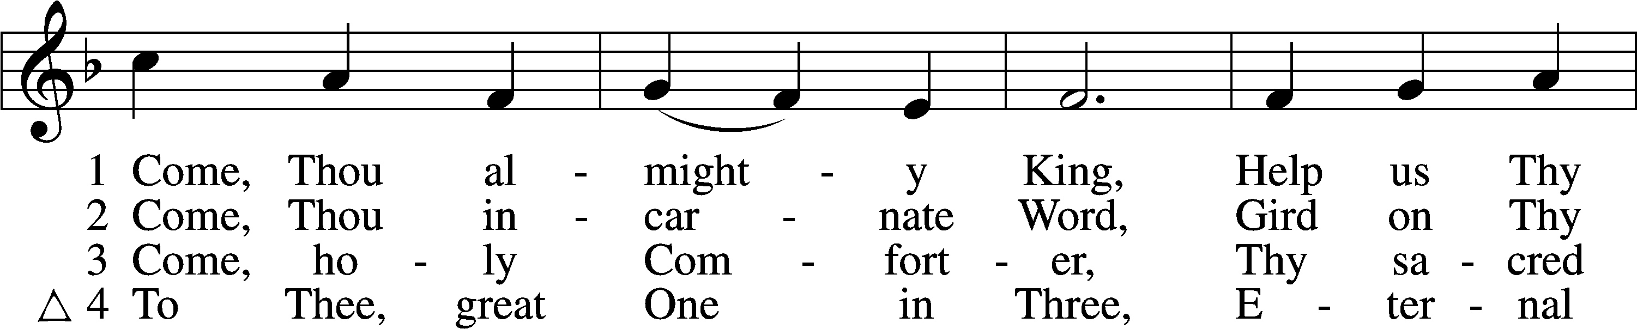
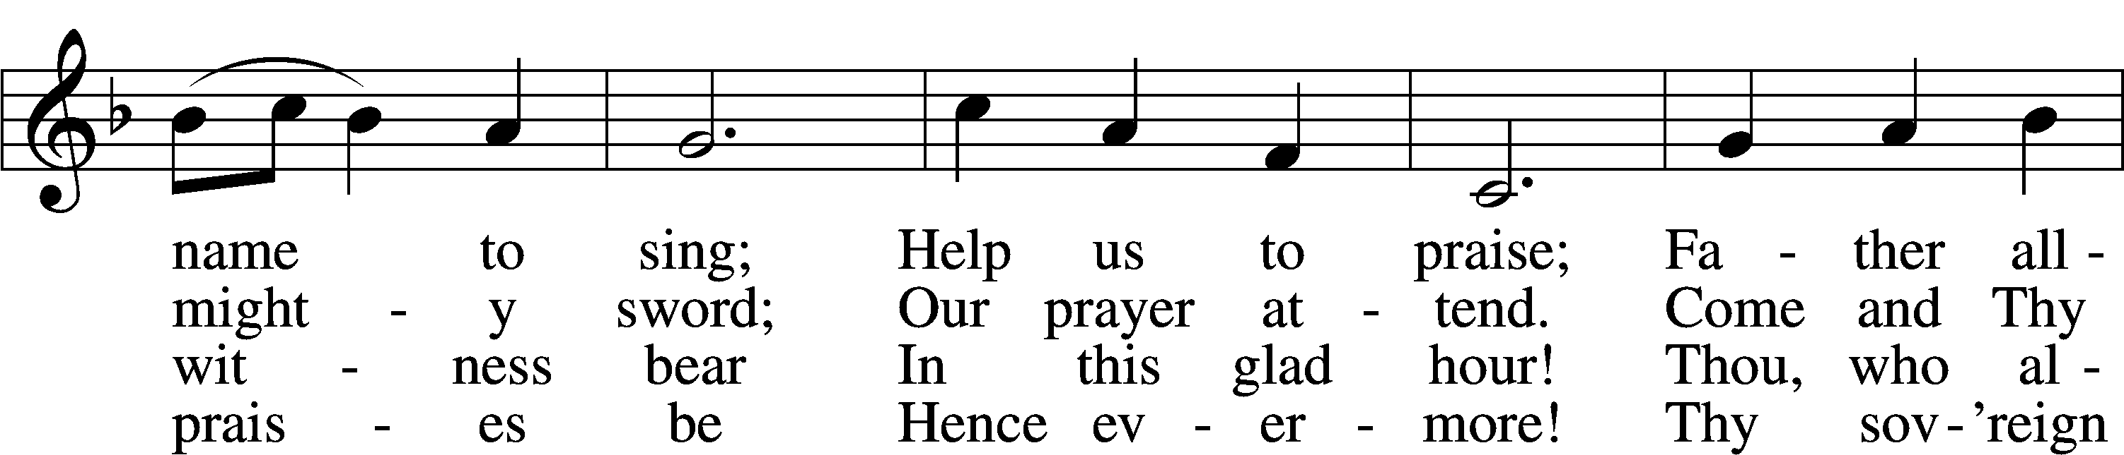
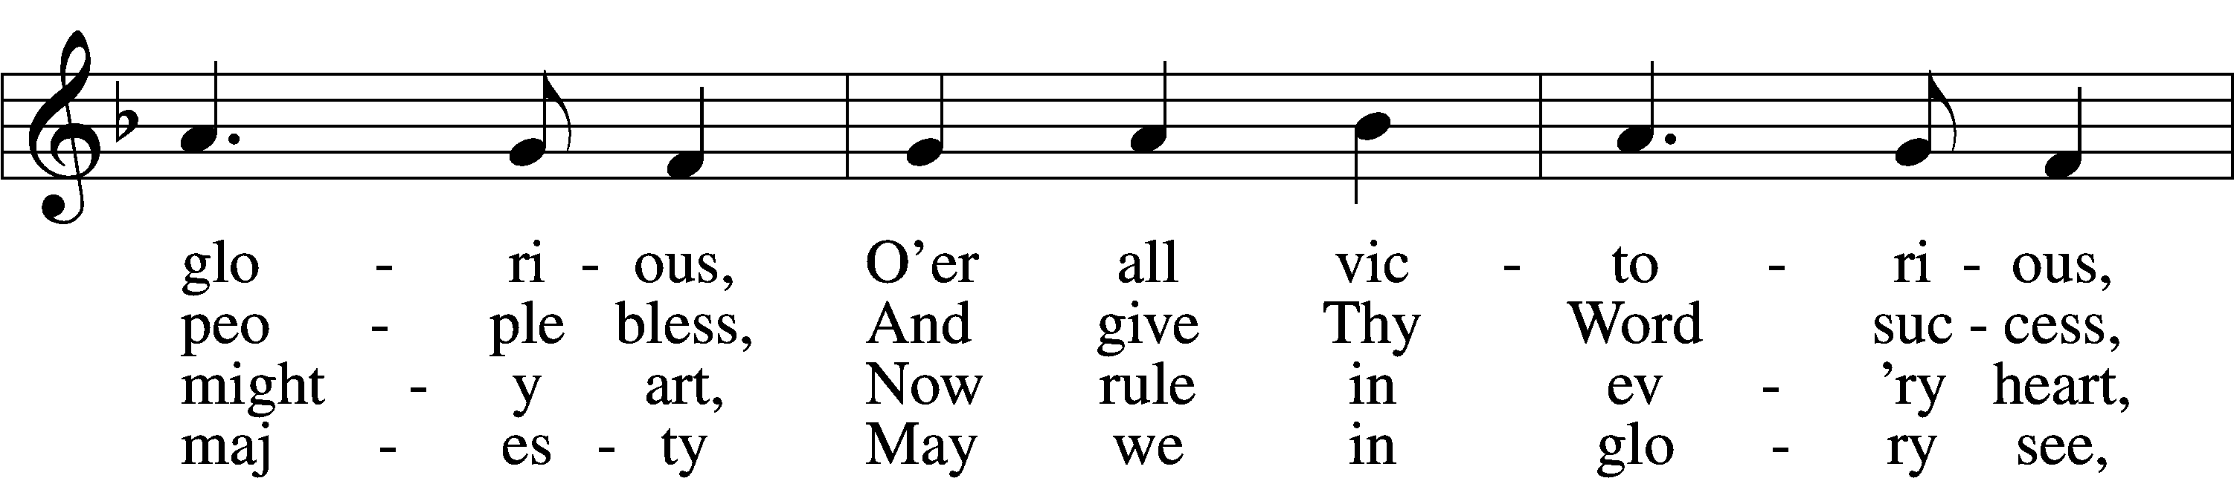
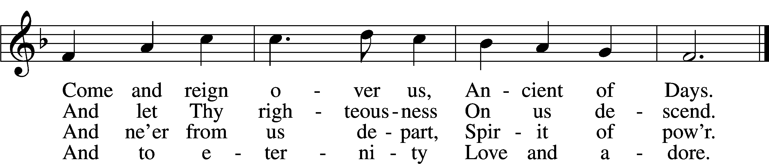

Invocation
P In the name of the Father and of the T Son and of the Holy Spirit.
C Amen.

P Our Father, You have promised to be with us forever. Reveal Yourself to us now. Endow us with Your spiritual gifts and sustain us with Your fruits.
C For our hearts are restless until they find their peace in you. Amen
Sit
The First Sunday in Advent
Scripture Reading Mark 1:1–8
1The beginning of the gospel of Jesus Christ, the Son of God.
2As it is written in Isaiah the prophet,
“Behold, I send my messenger before your face,
who will prepare your way,
3the voice of one crying in the wilderness:
‘Prepare the way of the Lord,
make his paths straight,’”
4John appeared, baptizing in the wilderness and proclaiming a baptism of repentance for the forgiveness of sins. 5And all the country of Judea and all Jerusalem were going out to him and were being baptized by him in the river Jordan, confessing their sins. 6Now John was clothed with camel’s hair and wore a leather belt around his waist and ate locusts and wild honey. 7And he preached, saying, “After me comes he who is mightier than I, the strap of whose sandals I am not worthy to stoop down and untie. 8I have baptized you with water, but he will baptize you with the Holy Spirit.”

357 O Come, O Come, Emmanuel
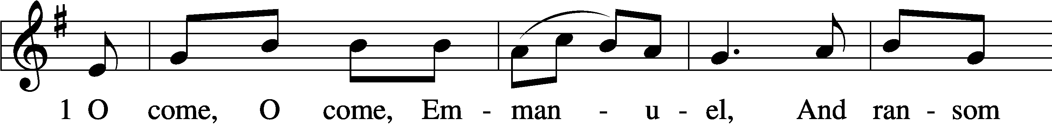
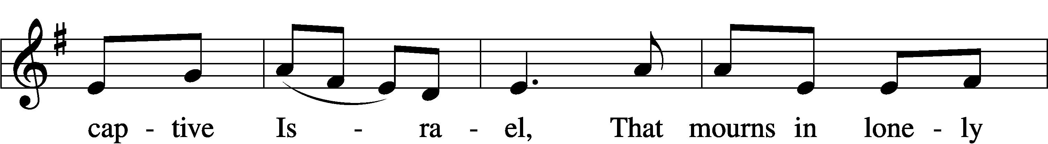
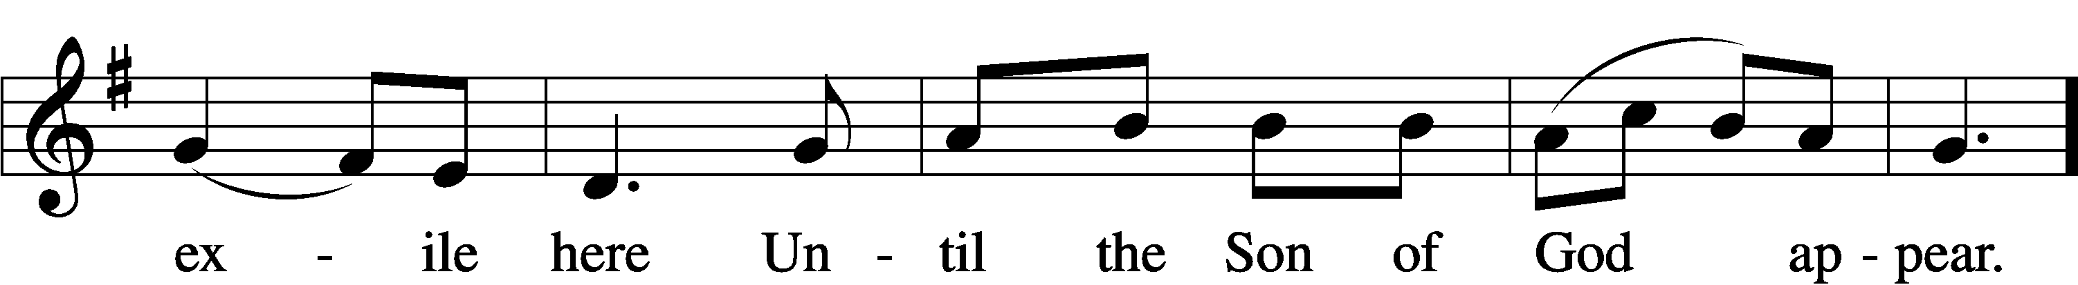
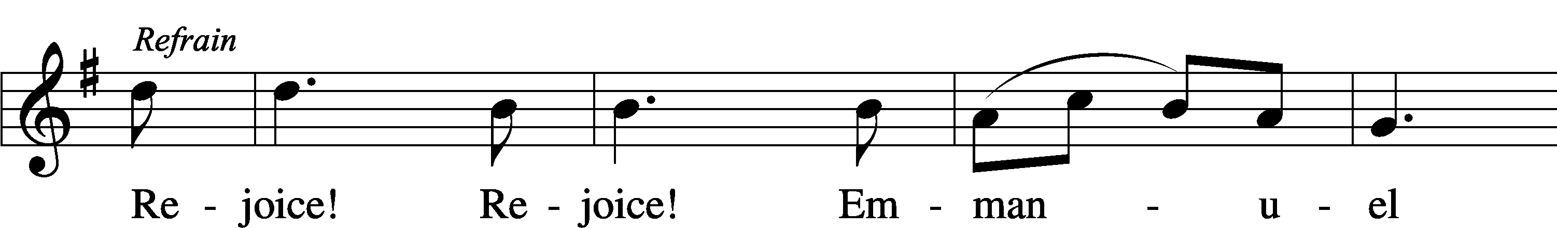
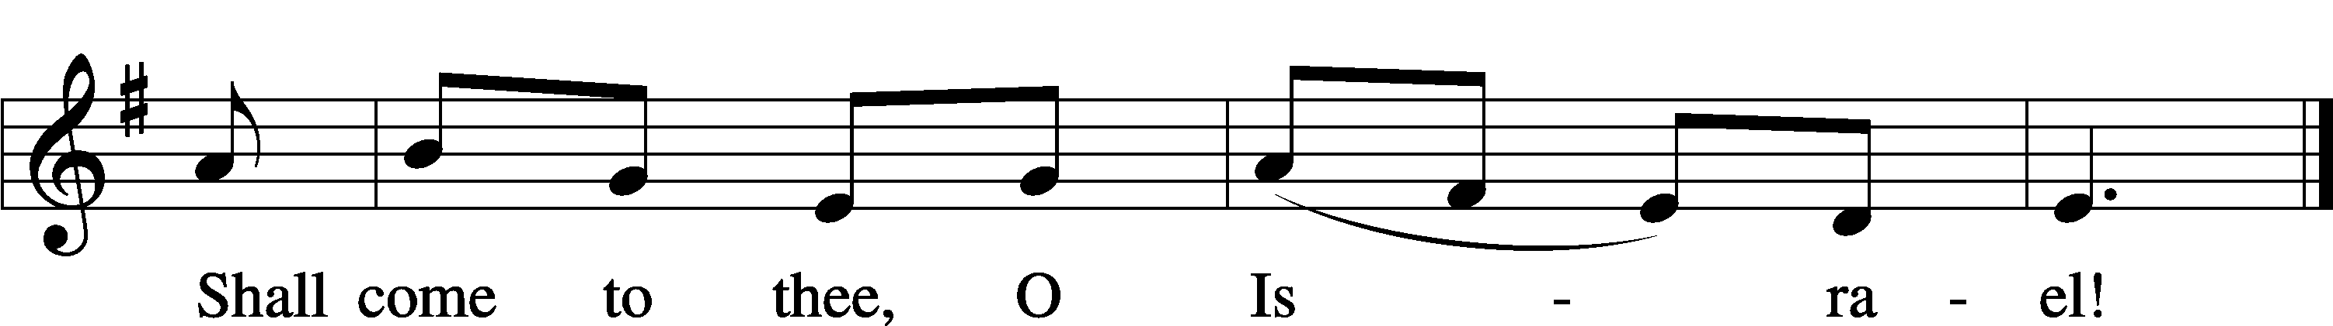

The Nativity of Our Lord
Scripture Reading Luke 2:1–7
1In those days a decree went out from Caesar Augustus that all the world should be registered. 2This was the first registration when Quirinius was governor of Syria. 3And all went to be registered, each to his own town. 4And Joseph also went up from Galilee, from the town of Nazareth, to Judea, to the city of David, which is called Bethlehem, because he was of the house and lineage of David, 5to be registered with Mary, his betrothed, who was with child. 6And while they were there, the time came for her to give birth. 7And she gave birth to her firstborn son and wrapped him in swaddling cloths and laid him in a manger, because there was no place for them in the inn.

387 Joy to the World
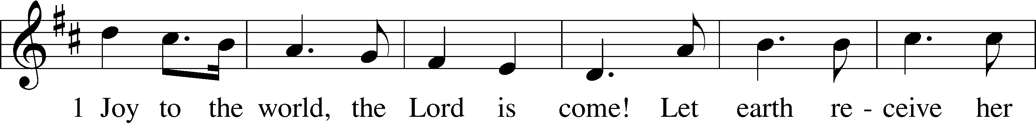
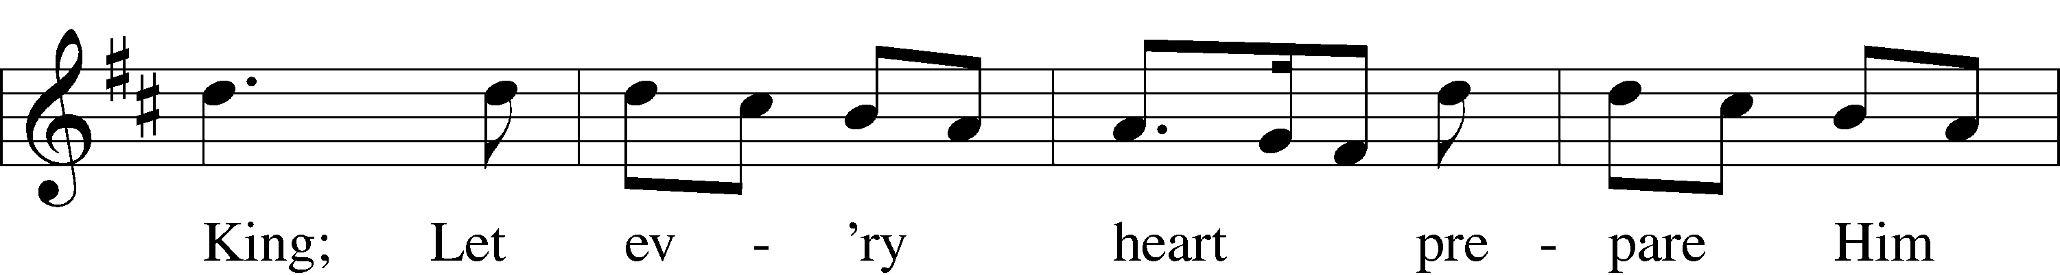
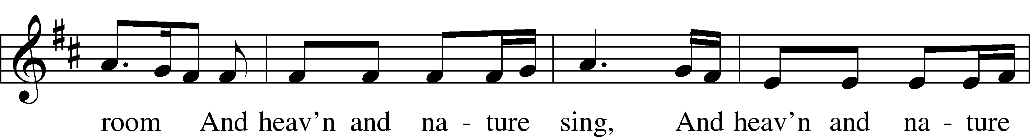
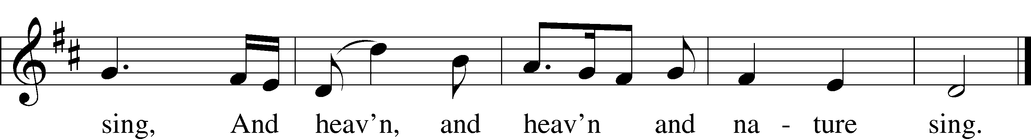
The Epiphany of Our Lord
Scripture Reading Matthew 2:1–2, 7–12
1Now after Jesus was born in Bethlehem of Judea in the days of Herod the king, behold, wise men from the east came to Jerusalem, 2saying, “Where is he who has been born king of the Jews? For we saw his star when it rose and have come to worship him.”
7Then Herod summoned the wise men secretly and ascertained from them what time the star had appeared. 8And he sent them to Bethlehem, saying, “Go and search diligently for the child, and when you have found him, bring me word, that I too may come and worship him.” 9After listening to the king, they went on their way. And behold, the star that they had seen when it rose went before them until it came to rest over the place where the child was. 10When they saw the star, they rejoiced exceedingly with great joy. 11And going into the house they saw the child with Mary his mother, and they fell down and worshiped him. Then, opening their treasures, they offered him gifts, gold and frankincense and myrrh. 12And being warned in a dream not to return to Herod, they departed to their own country by another way.

394 Songs of Thankfulness and Praise
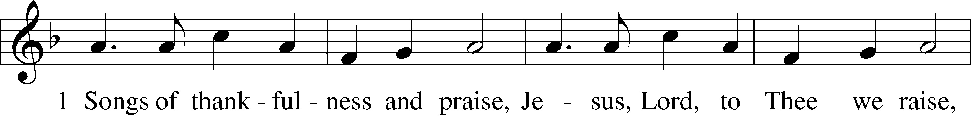
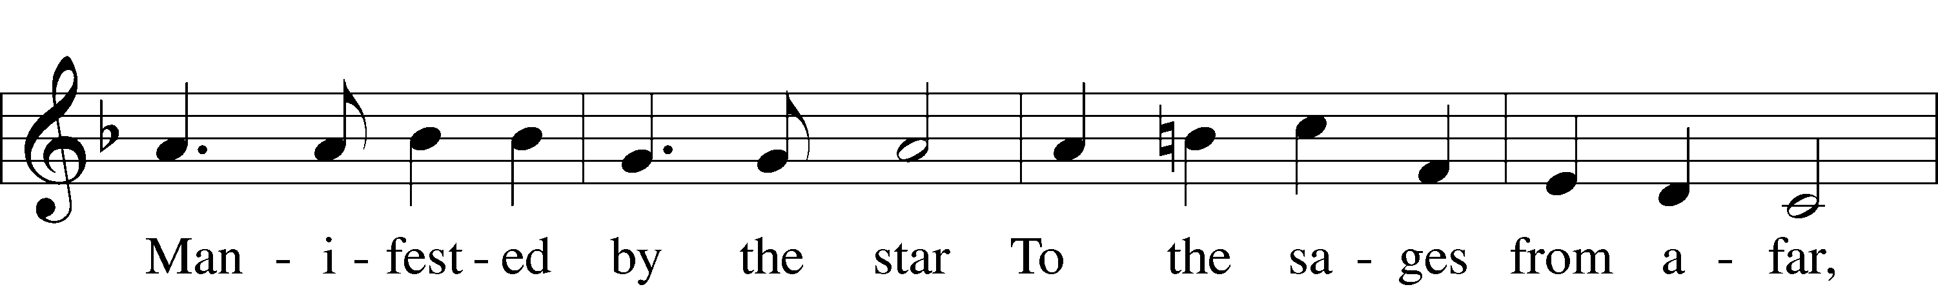
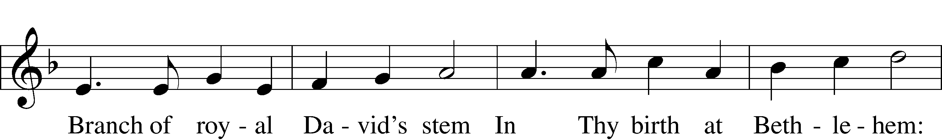
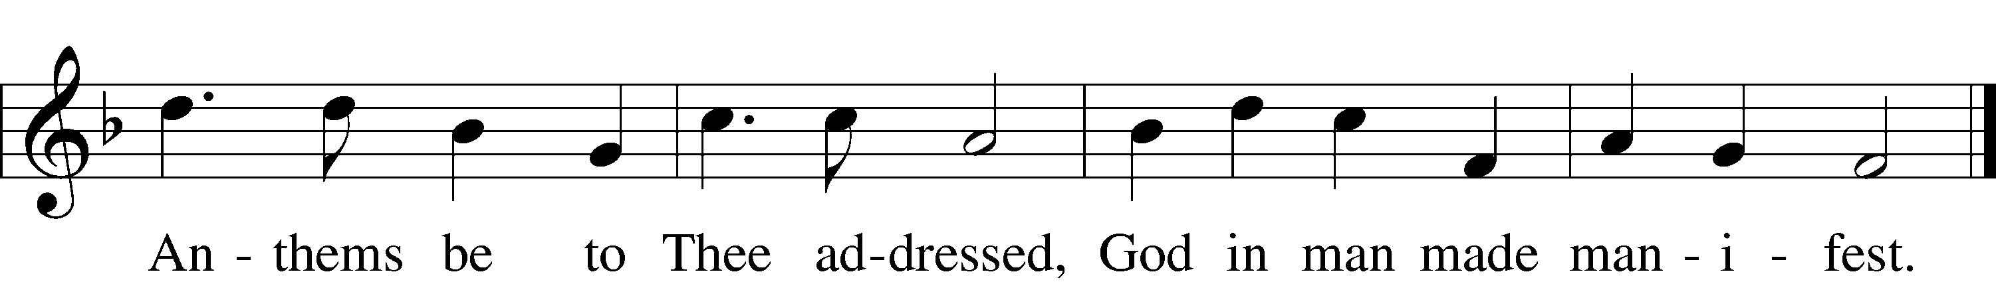
The Transfiguration of Our Lord
Scripture Reading Matthew 17:1–9
1After six days Jesus took with him Peter and James, and John his brother, and led them up a high mountain by themselves. 2And he was transfigured before them, and his face shone like the sun, and his clothes became white as light. 3And behold, there appeared to them Moses and Elijah, talking with him. 4And Peter said to Jesus, “Lord, it is good that we are here. If you wish, I will make three tents here, one for you and one for Moses and one for Elijah.” 5He was still speaking when, behold, a bright cloud overshadowed them, and a voice from the cloud said, “This is my beloved Son, with whom I am well pleased; listen to him.” 6When the disciples heard this, they fell on their faces and were terrified. 7But Jesus came and touched them, saying, “Rise, and have no fear.” 8And when they lifted up their eyes, they saw no one but Jesus only.
9And as they were coming down the mountain, Jesus commanded them, “Tell no one the vision, until the Son of Man is raised from the dead.”

414 ’Tis Good, Lord, to Be Here
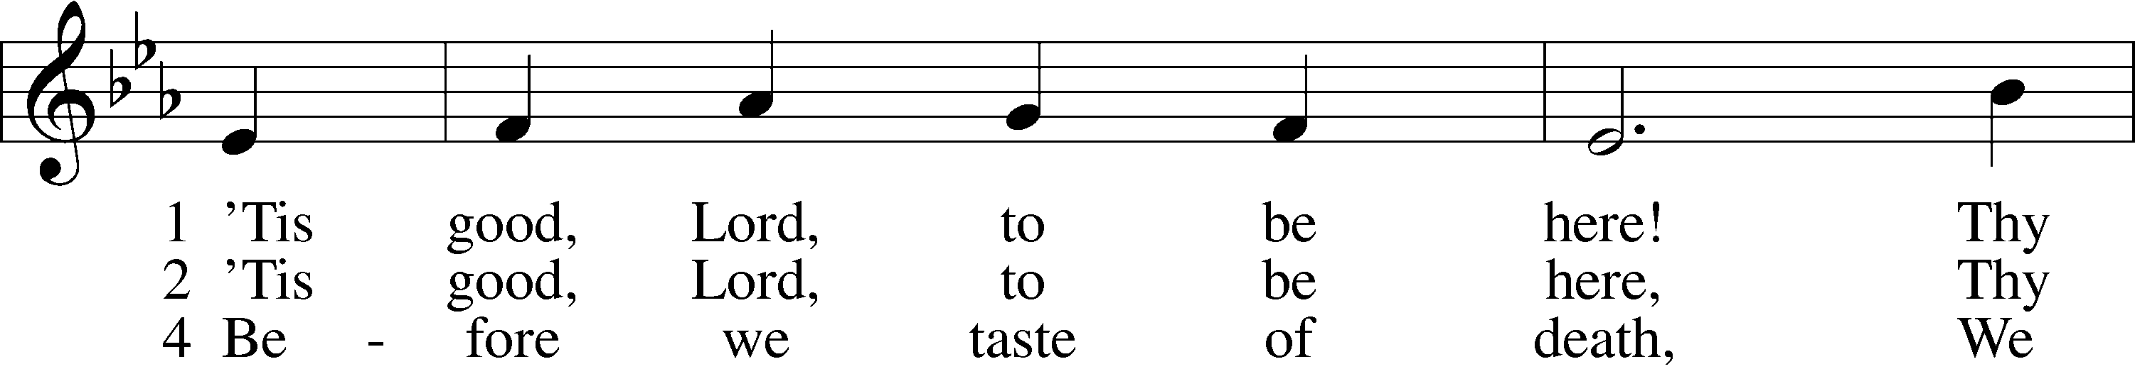
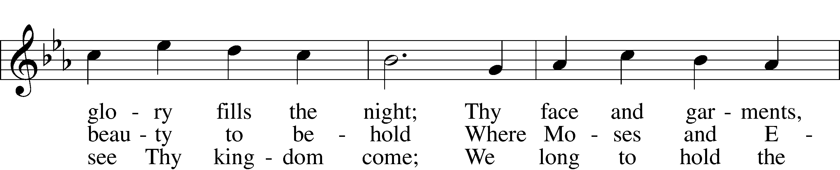
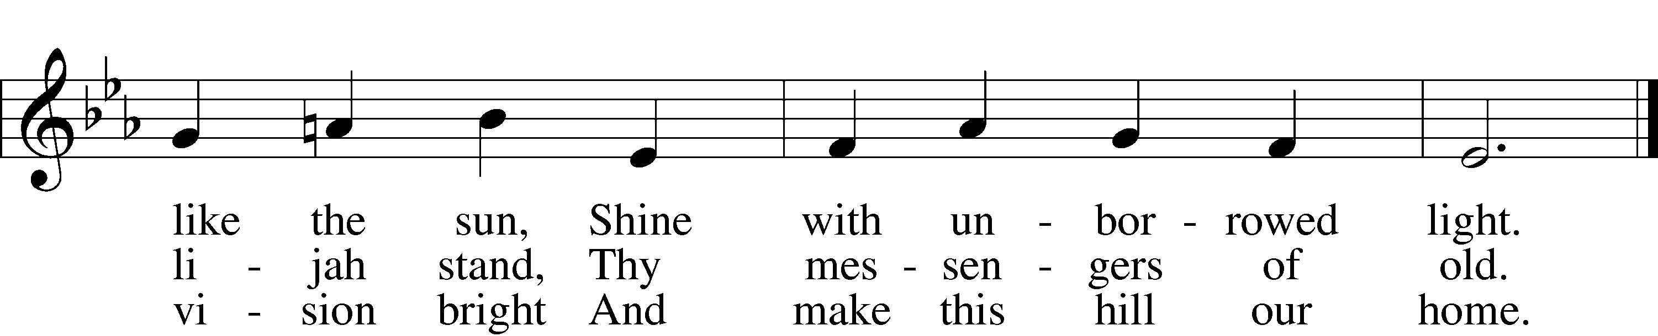

Ash Wednesday
Scripture Reading Isaiah 53:3–6
3He was despised and rejected by men;
a man of sorrows, and acquainted with grief;
and as one from whom men hide their faces
he was despised, and we esteemed him not.
4Surely he has borne our griefs
and carried our sorrows;
yet we esteemed him stricken,
smitten by God, and afflicted.
5But he was wounded for our transgressions;
he was crushed for our iniquities;
upon him was the chastisement that brought us peace,
and with his stripes we are healed.
6All we like sheep have gone astray;
we have turned every one to his own way;
and the Lord has laid on him
the iniquity of us all.

440 Jesus, I Will Ponder Now
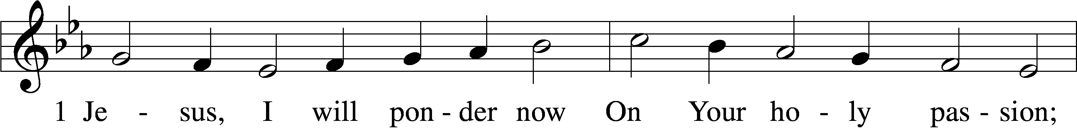
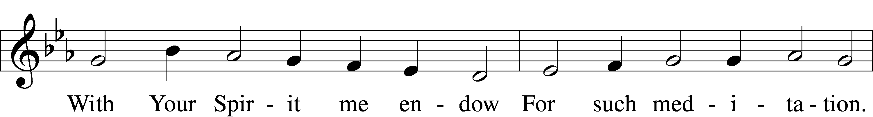
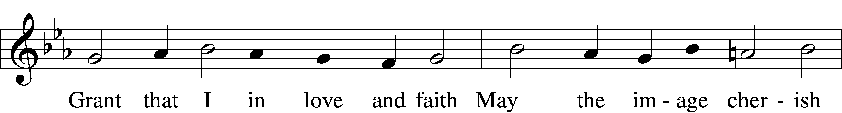
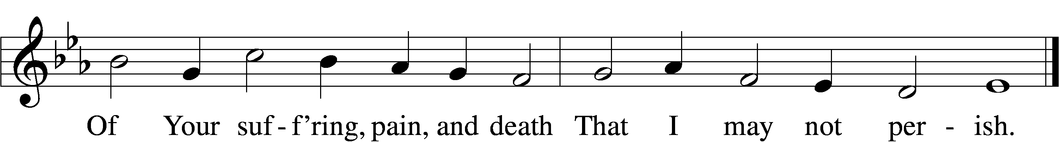

Palm Sunday
Scripture Reading Matthew 21:1–9
1When they drew near to Jerusalem and came to Bethphage, to the Mount of Olives, then Jesus sent two disciples, 2saying to them, “Go into the village in front of you, and immediately you will find a donkey tied, and a colt with her. Untie them and bring them to me. 3If anyone says anything to you, you shall say, ‘The Lord needs them,’ and he will send them at once.” 4This took place to fulfill what was spoken by the prophet, saying,
5“Say to the daughter of Zion,
‘Behold, your king is coming to you,
humble, and mounted on a donkey,
and on a colt, the foal of a beast of burden.’”
6The disciples went and did as Jesus had directed them. 7They brought the donkey and the colt and put on them their cloaks, and he sat on them. 8Most of the crowd spread their cloaks on the road, and others cut branches from the trees and spread them on the road. 9And the crowds that went before him and that followed him were shouting, “Hosanna to the Son of David! Blessed is he who comes in the name of the Lord! Hosanna in the highest!”

443 Hosanna, Loud Hosanna
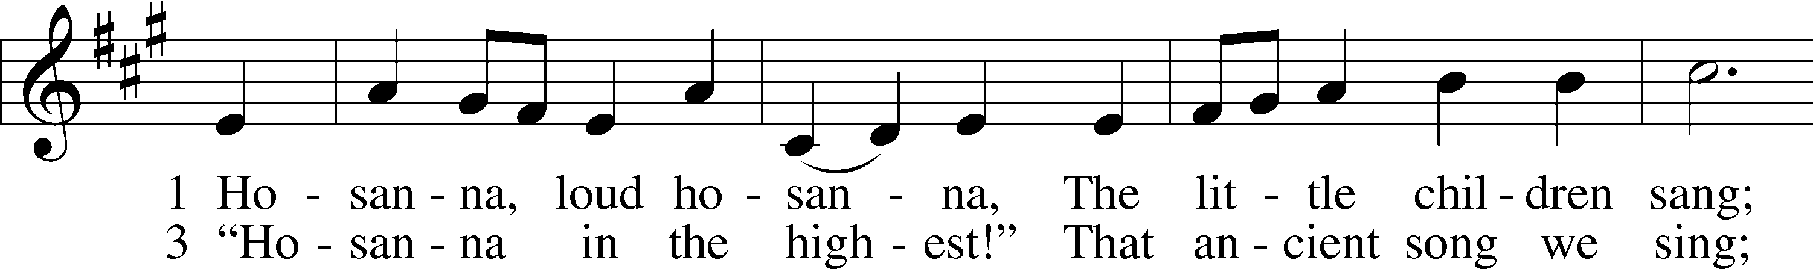
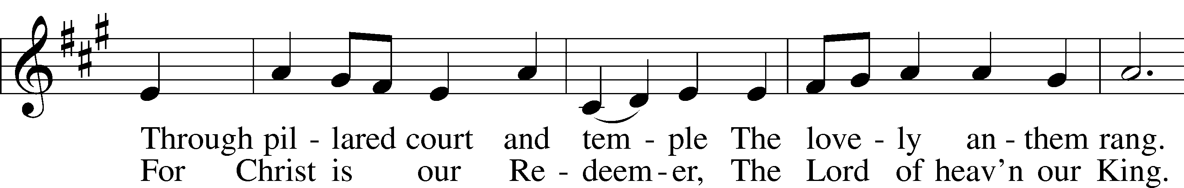
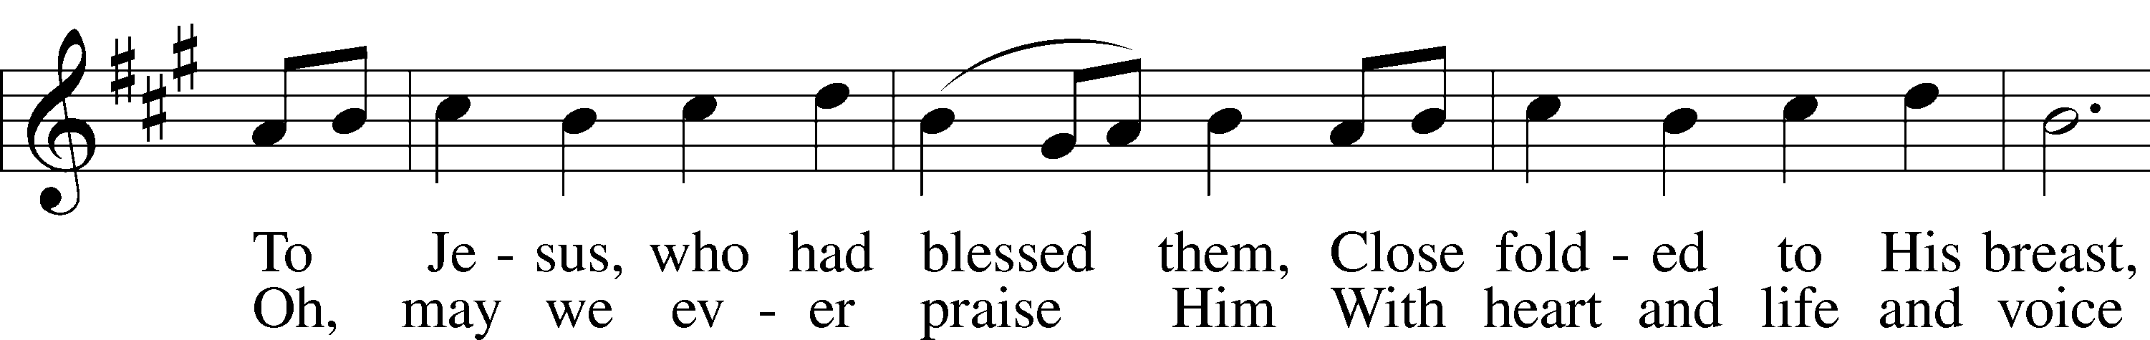
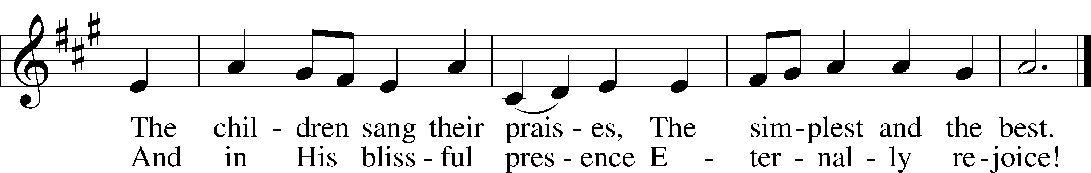

Maundy Thursday
Scripture Reading Matthew 26:26–29
26Now as they were eating, Jesus took bread, and after blessing it broke it and gave it to the disciples, and said, “Take, eat; this is my body.” 27And he took a cup, and when he had given thanks he gave it to them, saying, “Drink of it, all of you, 28for this is my blood of the covenant, which is poured out for many for the forgiveness of sins. 29I tell you I will not drink again of this fruit of the vine until that day when I drink it new with you in my Father’s kingdom.”

622 Lord Jesus Christ, You Have Prepared
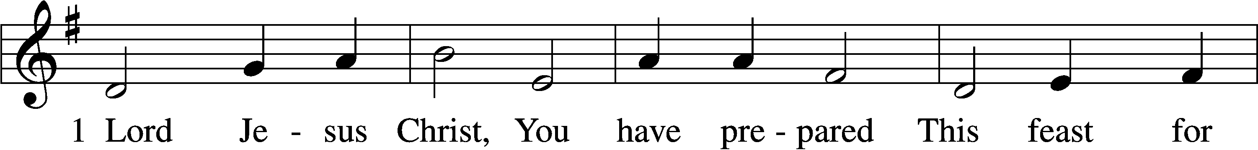
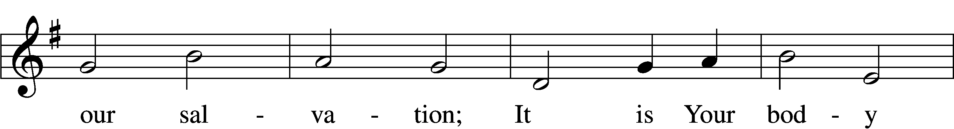
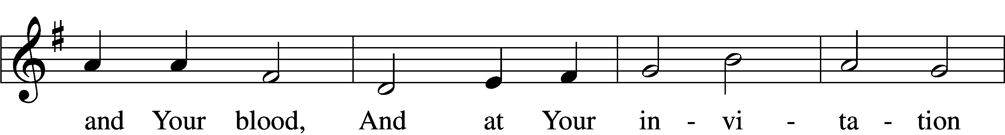

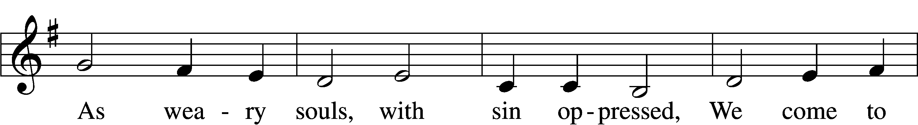
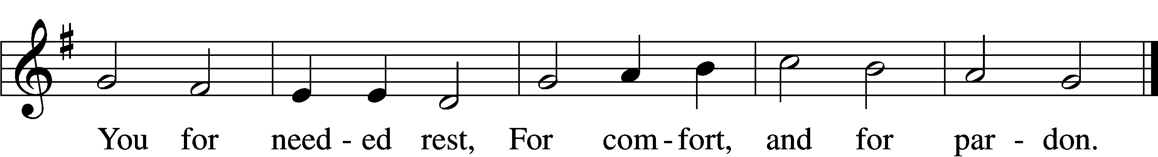

Stand

Service of the Sacrament
The Words of Our Lord
P Our Lord Jesus Christ, on the night when He was betrayed, took bread, and when He had given thanks, He broke it and gave it to the disciples and said: “Take, eat; this is My T body, which is given for you. This do in remembrance of Me.”

In the same way also, He took the cup after supper, and when He had given thanks, He gave it to them, saying: “Drink of it, all of you; this cup is the new testament in My T blood, which is shed for you for the forgiveness of sins. This do, as often as you drink it, in remembrance of Me.”

Pax Domini
P The peace of the Lord be with you always.
C Amen.

Sit

Distribution

Distribution Hymns
619 Thy Body, Given for Me, O Savior
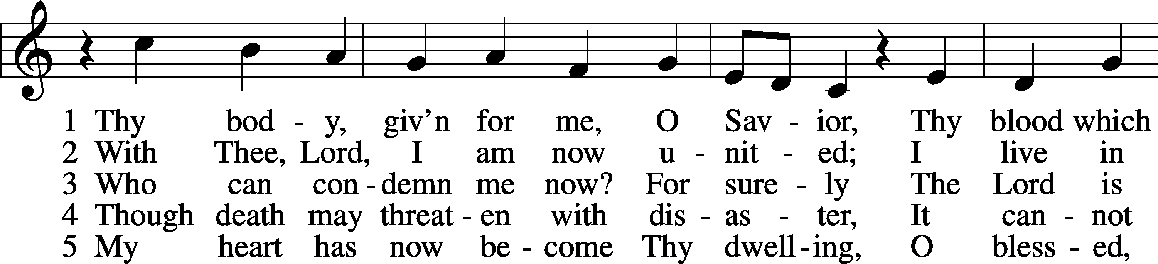
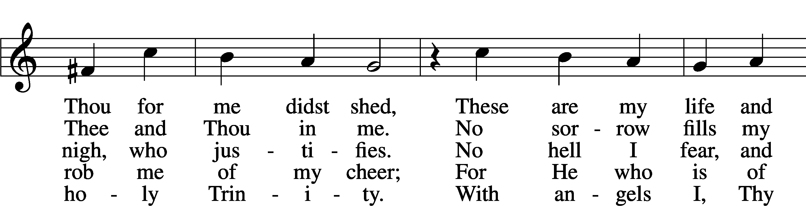
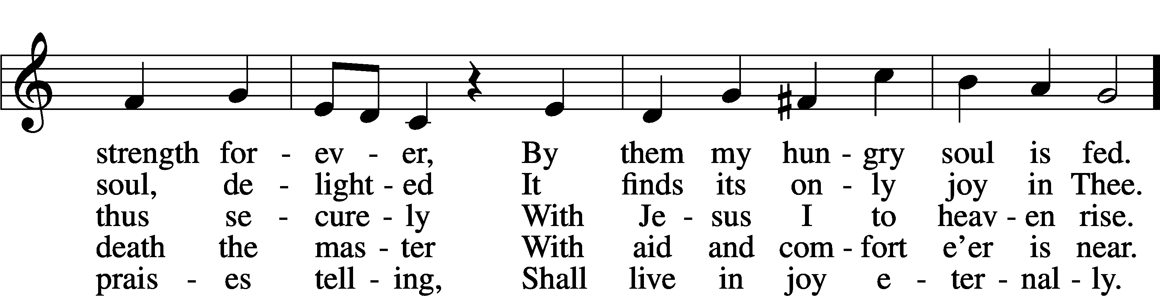
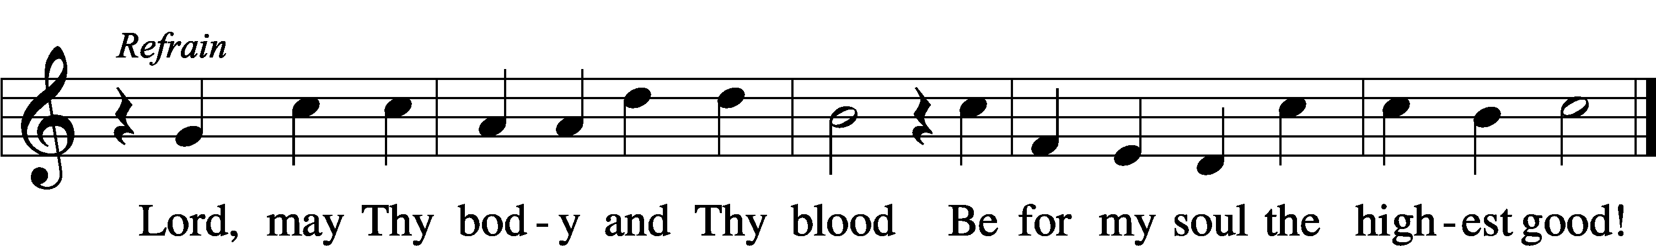

611 Chief of Sinners Though I Be
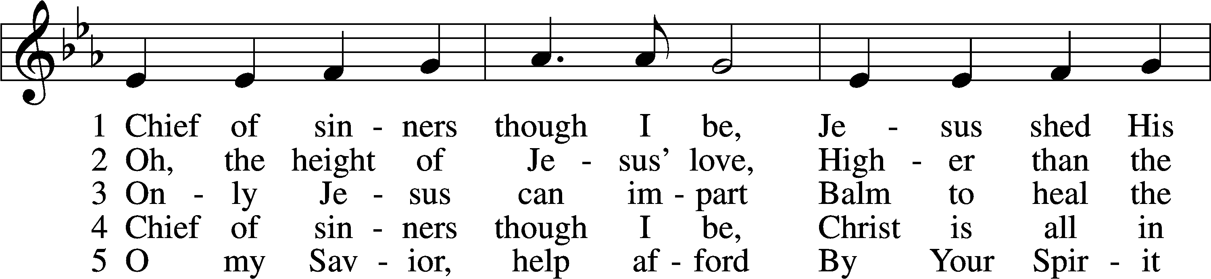
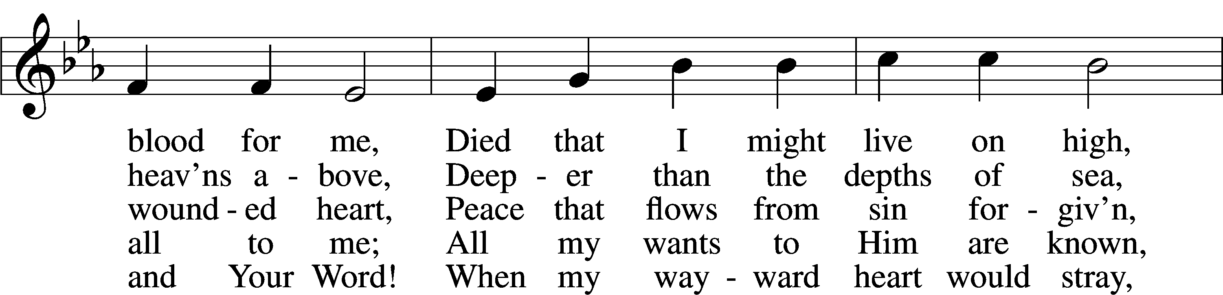
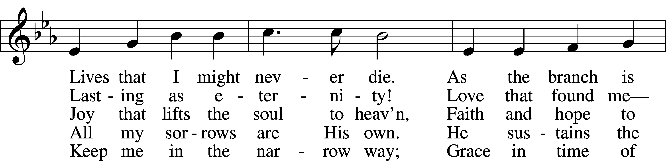
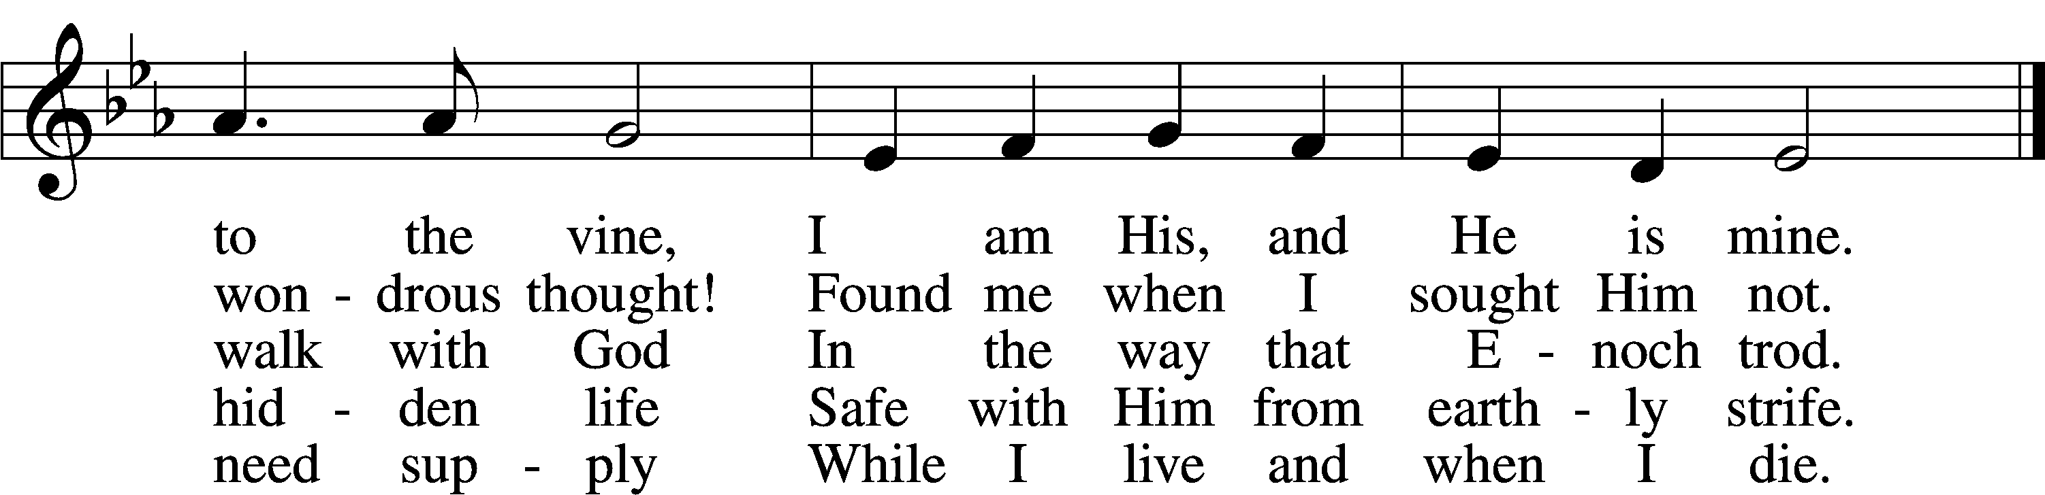

Good Friday
Reading John 19:16–18, 28–30
16So he delivered him over to them to be crucified.
So they took Jesus, 17and he went out, bearing his own cross, to the place called the place of a skull, which in Aramaic is called Golgotha. 18There they crucified him, and with him two others, one on either side, and Jesus between them.
28After this, Jesus, knowing that all was now finished, said (to fulfill the Scripture), “I thirst.” 29A jar full of sour wine stood there, so they put a sponge full of the sour wine on a hyssop branch and held it to his mouth. 30When Jesus had received the sour wine, he said, “It is finished,” and he bowed his head and gave up his spirit.

425 When I Survey the Wondrous Cross
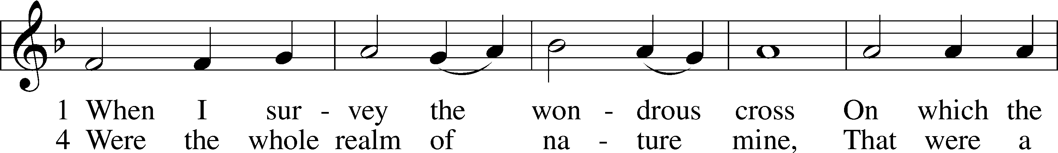
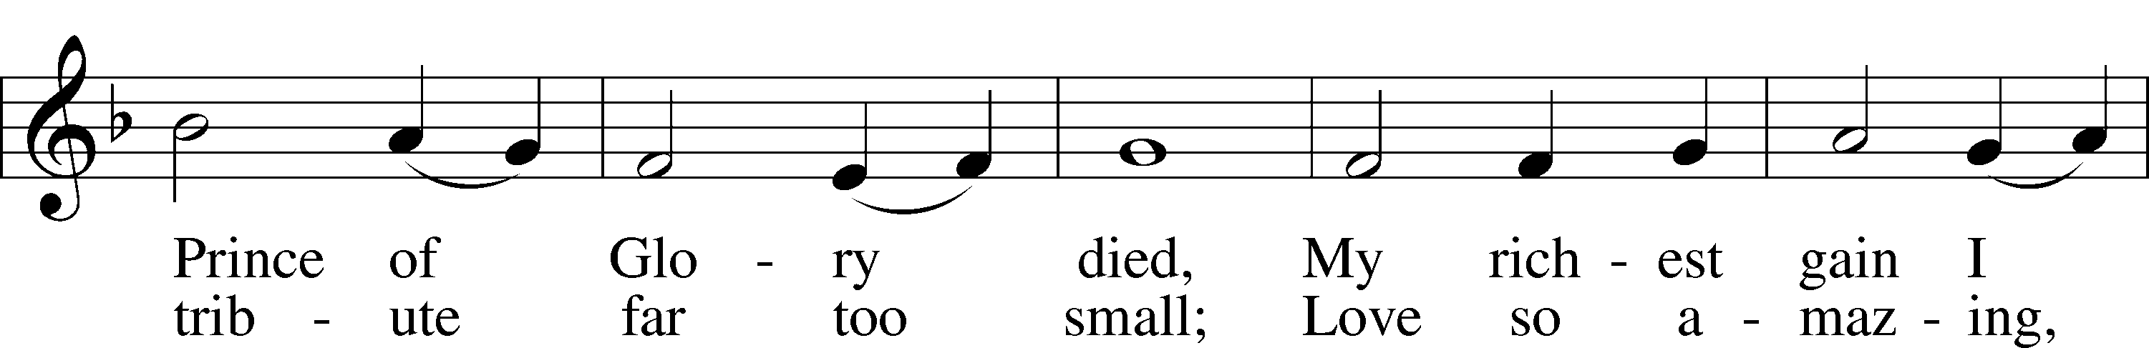
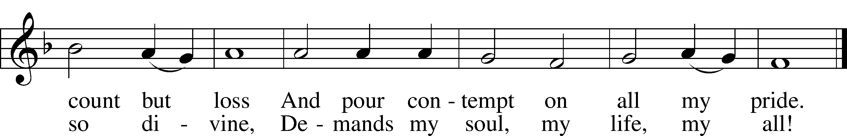

The Resurrection of Our Lord
Scripture Reading Luke 24:1–6
1But on the first day of the week, at early dawn, they went to the tomb, taking the spices they had prepared. 2And they found the stone rolled away from the tomb, 3but when they went in they did not find the body of the Lord Jesus. 4While they were perplexed about this, behold, two men stood by them in dazzling apparel. 5And as they were frightened and bowed their faces to the ground, the men said to them, “Why do you seek the living among the dead? 6He is not here, but has risen. Remember how he told you, while he was still in Galilee . . . .

469 Christ the Lord Is Risen Today
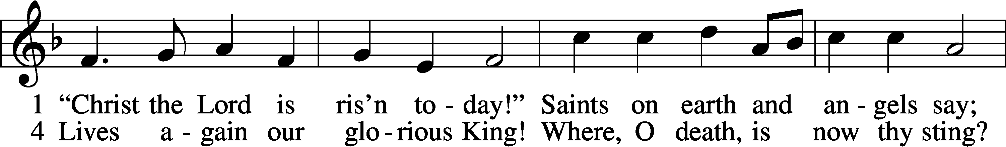
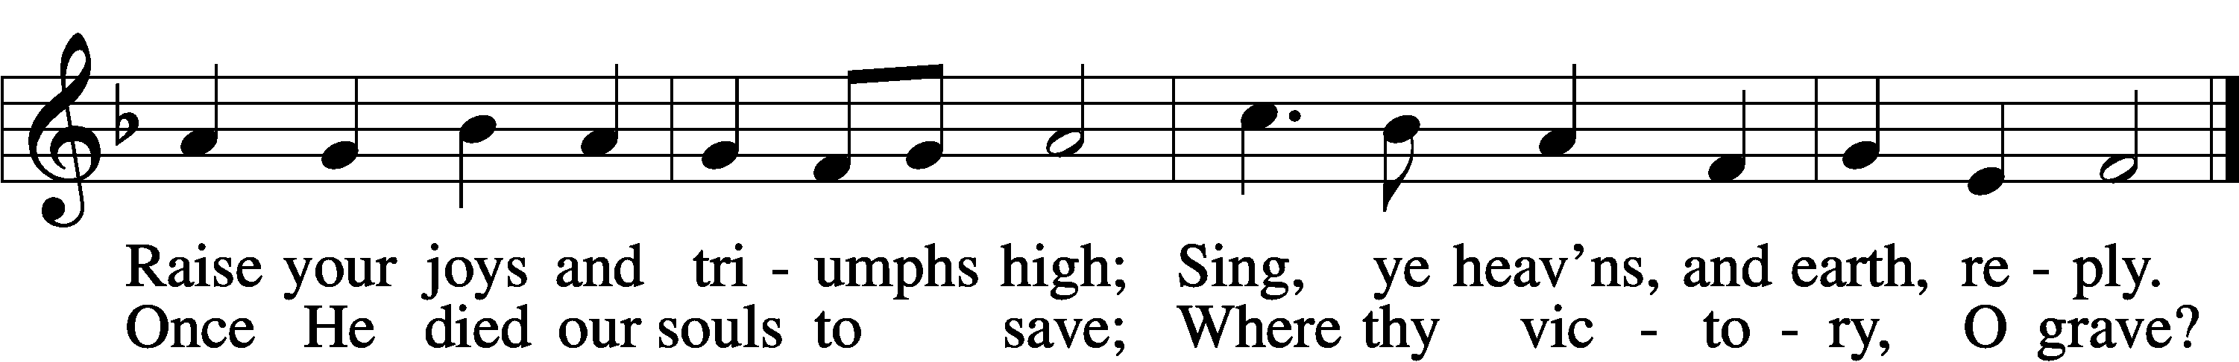
Stand
The Prayers
P God the Father, God the Son, and God the Holy Spirit, One in Three and Three in One,
C accept our praise for our creation, redemption and sanctification.
P O Father, Author of our creation, how majestic is Your name in all the earth.
C The moon and stars, the works of Your fingers, reflect Your glory.
P When man, the crown of Your creation, failed to reflect Your glory, You visited Him in the form of Your Son Jesus Christ.
C We are indeed thankful that Your image, which man lost, may be restored through faith in the suffering, death, resurrection and ascension of Your willing servant, Jesus.
P O Lord Jesus Christ, we humbly bring You our praises.
C For leaving the throne of Your glory, we give You thanks.
P For dwelling among us as true man, we give You thanks.
C For being tempted as we are, we are thankful.
P For taking upon Yourself our sins and accepting the punishment for them, we give You thanks.
C For justifying us before the Father, we give You thanks.
P We confess that we have repaid You miserably for this gift of salvation.
C For Your loving-kindness we have repaid You with lovelessness.
P For Your love and zeal in working out our salvation we have repaid You with apathy and indifference.
C For these our miserable offenses forgive us, O Lord.
P O Holy Spirit, enter our hearts, we pray.
C Help us to endure tribulation with patience.
P Fill our hearts with hope.
C Help us to accept the forgiveness earned for us by Christ. Grant us your peace.

(Special intercessions)
After each segment:
P Lord, in Your mercy,
C Hear our prayer.

After prayers:
P O Father, Son, and Holy Spirit, ever One in Three and Three in One, accept the praise we bring from grateful hearts.
C In Jesus’ name we pray. Amen
Lord’s Prayer
C Our Father who art in heaven,
hallowed be Thy name,
Thy kingdom come,
Thy will be done on earth
as it is in heaven;
give us this day our daily bread;
and forgive us our trespasses
as we forgive those
who trespass against us;
and lead us not into temptation,
but deliver us from evil.
For Thine is the kingdom
and the power and the glory
forever and ever. Amen.

Sit

The Ascension of Our Lord
Scripture Reading Acts 1:6–11
6So when they had come together, they asked him, “Lord, will you at this time restore the kingdom to Israel?” 7He said to them, “It is not for you to know times or seasons that the Father has fixed by his own authority. 8But you will receive power when the Holy Spirit has come upon you, and you will be my witnesses in Jerusalem and in all Judea and Samaria, and to the end of the earth.” 9And when he had said these things, as they were looking on, he was lifted up, and a cloud took him out of their sight. 10And while they were gazing into heaven as he went, behold, two men stood by them in white robes, 11and said, “Men of Galilee, why do you stand looking into heaven? This Jesus, who was taken up from you into heaven, will come in the same way as you saw him go into heaven.”

493 A Hymn of Glory Let Us Sing
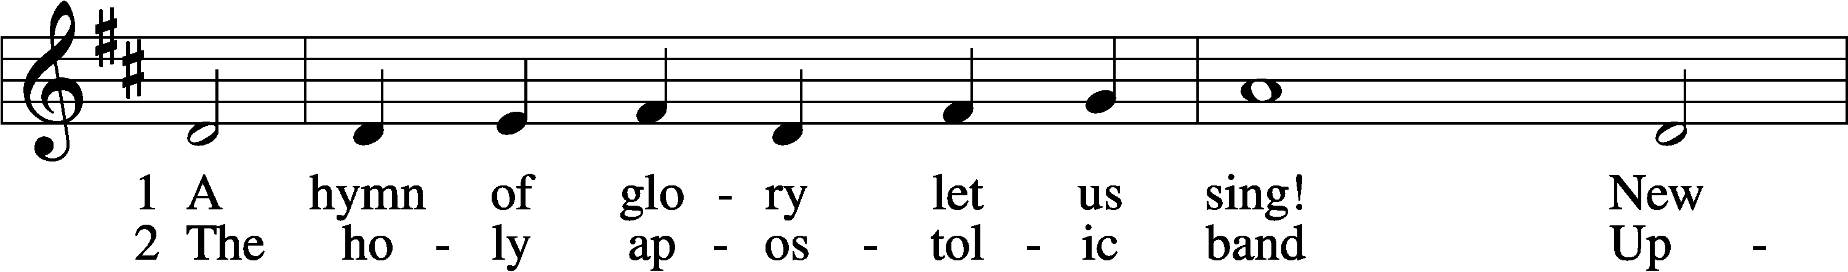
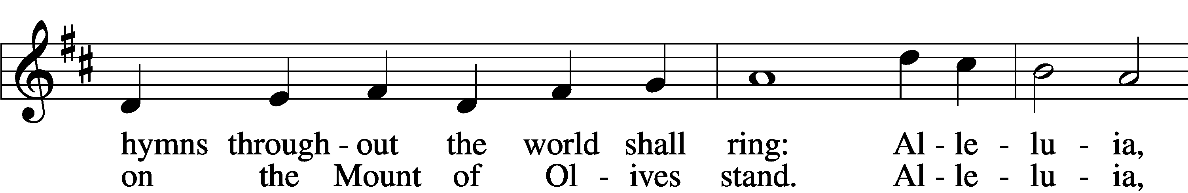
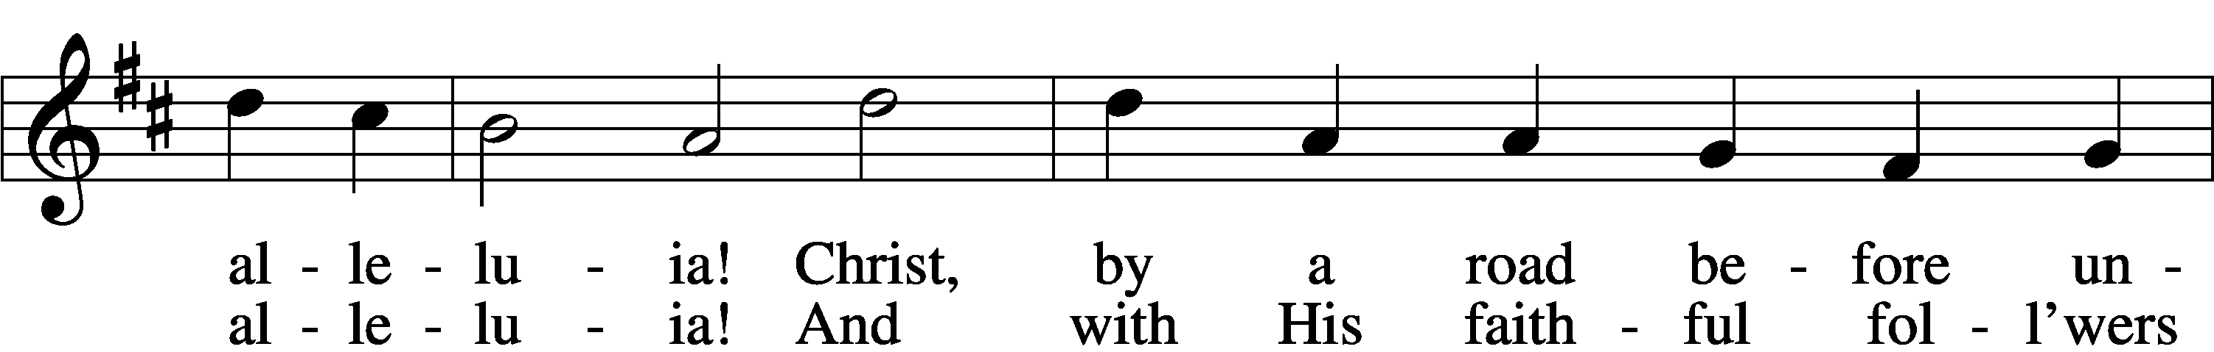
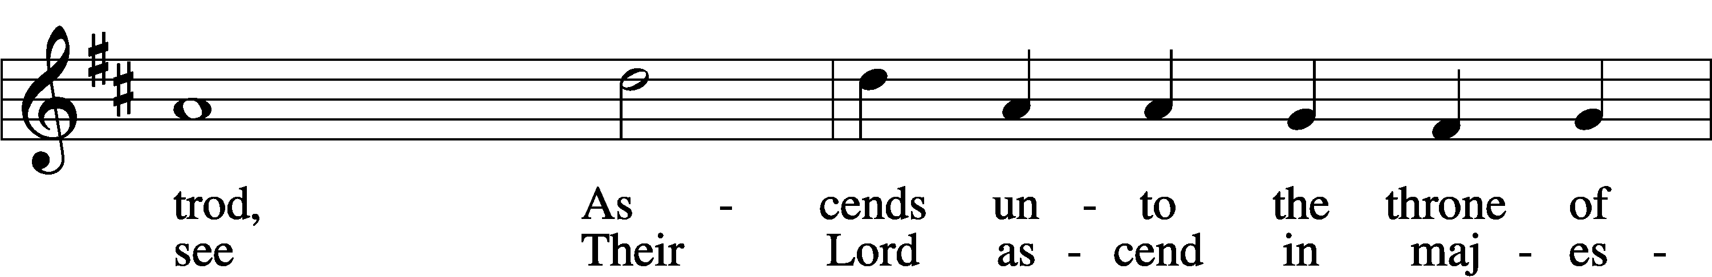
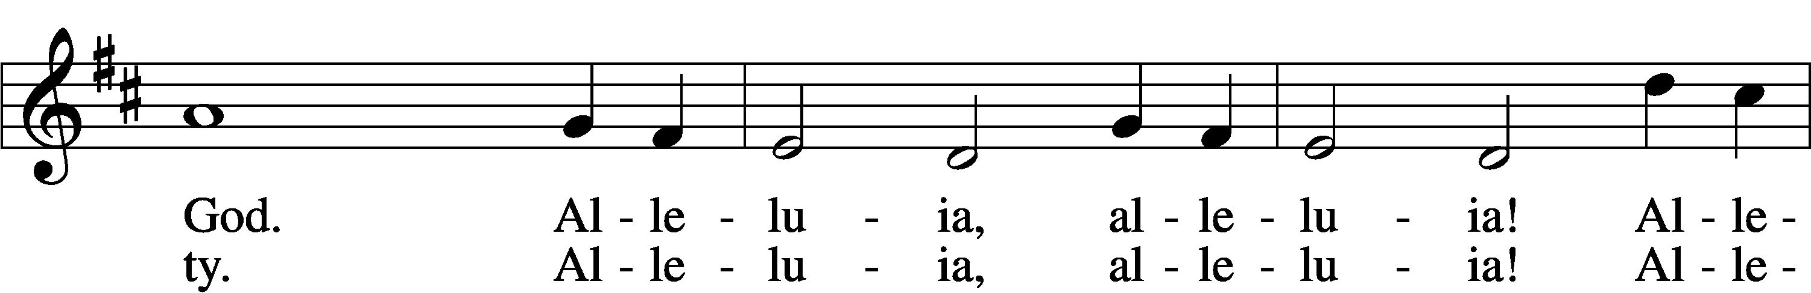
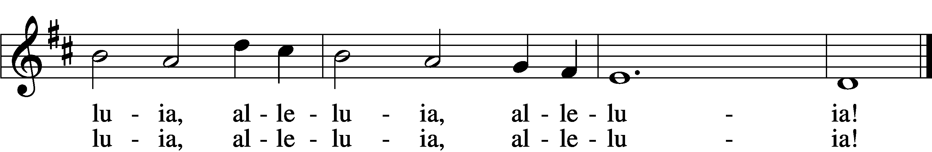

Pentecost
Scripture Reading Acts 2:1–4
1When the day of Pentecost arrived, they were all together in one place. 2And suddenly there came from heaven a sound like a mighty rushing wind, and it filled the entire house where they were sitting. 3And divided tongues as of fire appeared to them and rested on each one of them. 4And they were all filled with the Holy Spirit and began to speak in other tongues as the Spirit gave them utterance.

496 Holy Spirit, Light Divine
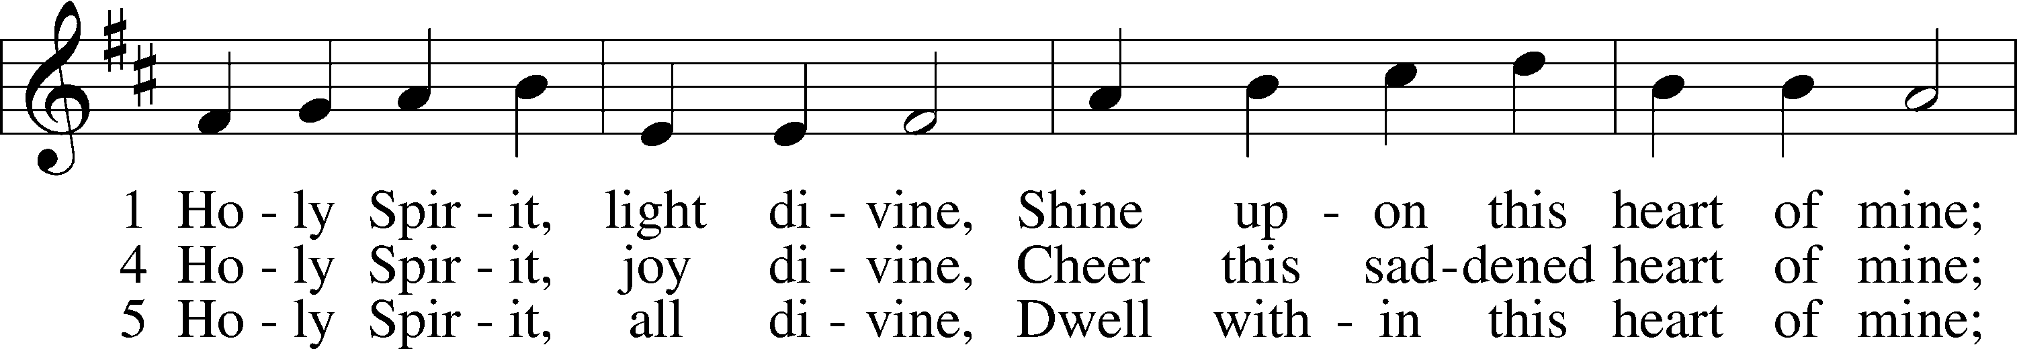
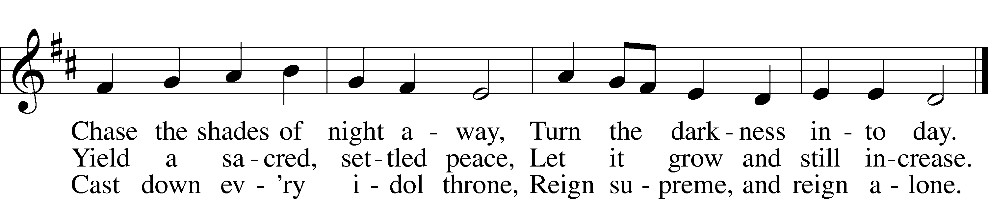

The Holy Trinity
Scripture Reading Matthew 28:16–20
16Now the eleven disciples went to Galilee, to the mountain to which Jesus had directed them. 17And when they saw him they worshiped him, but some doubted. 18And Jesus came and said to them, “All authority in heaven and on earth has been given to me. 19Go therefore and make disciples of all nations, baptizing them in the name of the Father and of the Son and of the Holy Spirit, 20teaching them to observe all that I have commanded you. And behold, I am with you always, to the end of the age.”

507 Holy, Holy, Holy
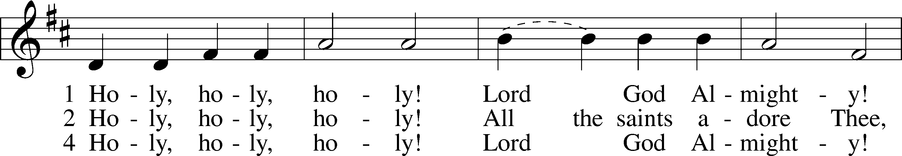
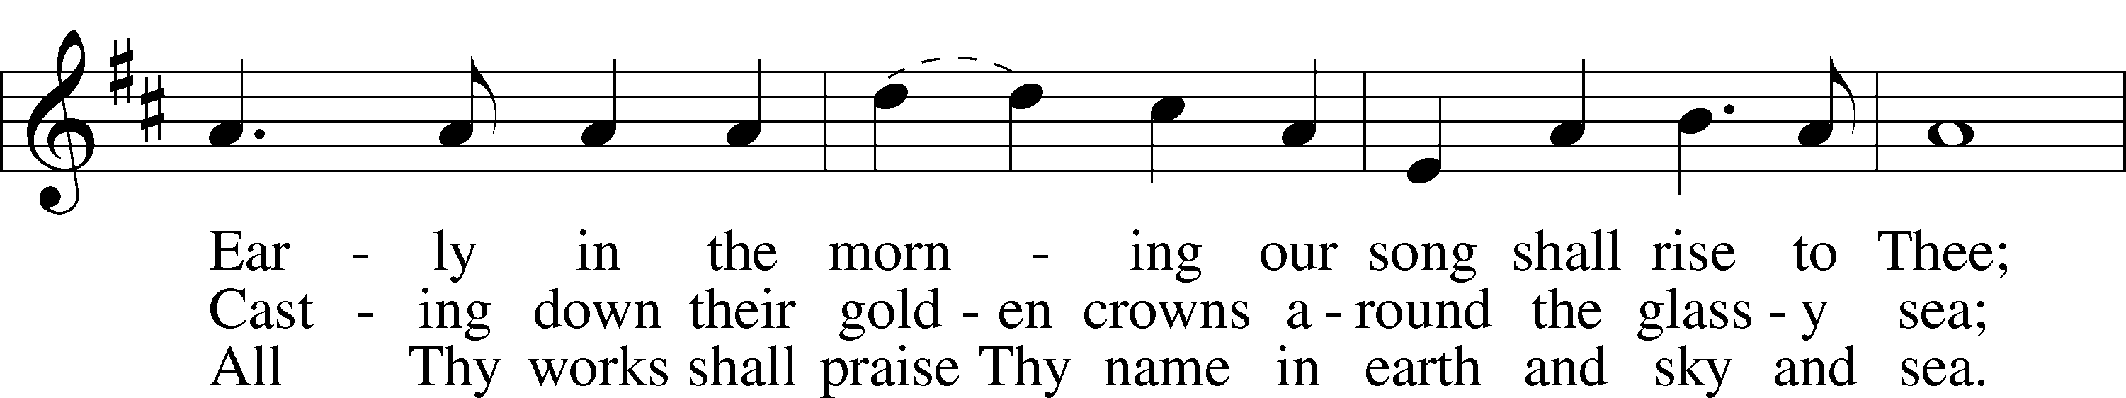
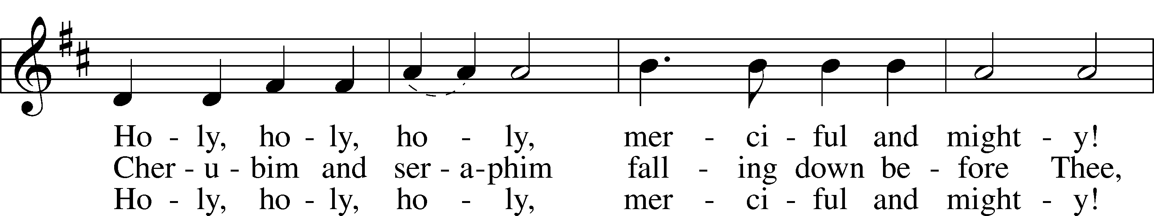
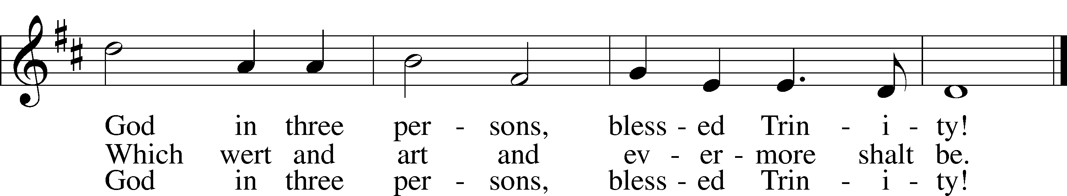

Stand

The Closing Prayer
P Almighty and everlasting God, since You have given us, Your servants, grace to acknowledge the glory of the eternal Trinity by the confession of a true faith, and to worship the true Unity in the power of Your divine majesty, keep us also steadfast in this true faith and worship, and defend us ever from all our adversaries;
C For you, O Father, Son and Holy Spirit, live and reign, one God, now and forever. Amen

Benediction
P The Lord bless you and keep you.
The Lord make His face shine on you and be gracious to you.
The Lord look upon you with favor and T give you peace.
C Amen.

The Closing Hymn

805 Praise God, from Whom All Blessings Flow
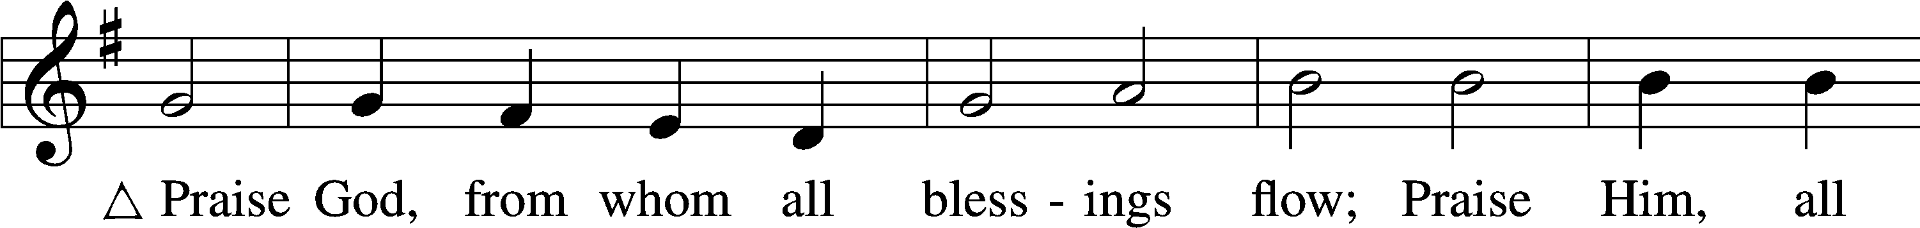
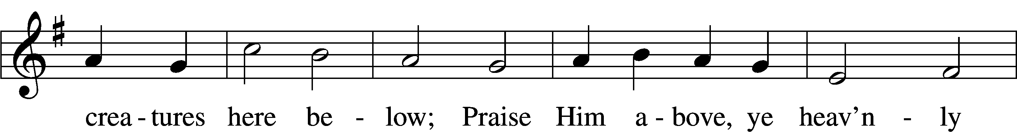
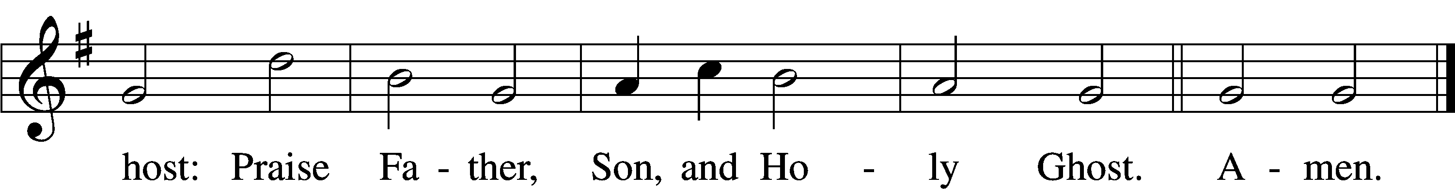

Sit

Announcements

Closing Statement
P We go to live for Jesus.
C We go to share His love.

Acknowledgments
Unless otherwise indicated, Scripture quotations are from the ESV® Bible (The Holy Bible, English Standard Version®), copyright © 2001 by Crossway, a publishing ministry of Good News Publishers. Used by permission. All rights reserved.
Created by Lutheran Service Builder © 2023 Concordia Publishing House.

